

**Software Requirement Specification**

**On Demand Tutor System (ODTS)**

**Version: 1.0**

–HCM, May - 2024–

**Table of Contents**

**I. Record of Changes 3**

**II. Software Requirement Specification 4**

1. Product Overview 4

2. User Requirements 5

2.1 Actors 5

3. Functional Requirements 8

3.1 System Functional Overview 8

3.2 Feature 11

4. Requirement Appendix 16

# I. Record of Changes

| **Version** | **Date** | **A* M, D** | **In charge** | **Change Description** |
| --- | --- | --- | --- | --- |
| V1.0 | 17/2 | A, M | ThanhNTSE170542 | title, footnote,actor |
| V1.0 | 20/4 | A | ThanhNTSE170542 | actor descriptor, use case diagram |
| V1.0 | 20/4 | A | ThanhNTSE170542 | use case table |
| V1.0 | 21/4 | A | ThanhNTSE170542 | finished use case table description |
| V1.0 | 30/5 | A,M | ThanhNTSE170542 | update new diagram,  add scene description, screen authorization, database table description |
| V1.0 | 30/5 | A | ThanhNTSE170542 | Screenflow, database schema |

*A - Added M - Modified D - Deleted

# II. Software Requirement Specification

## 1. Product Overview

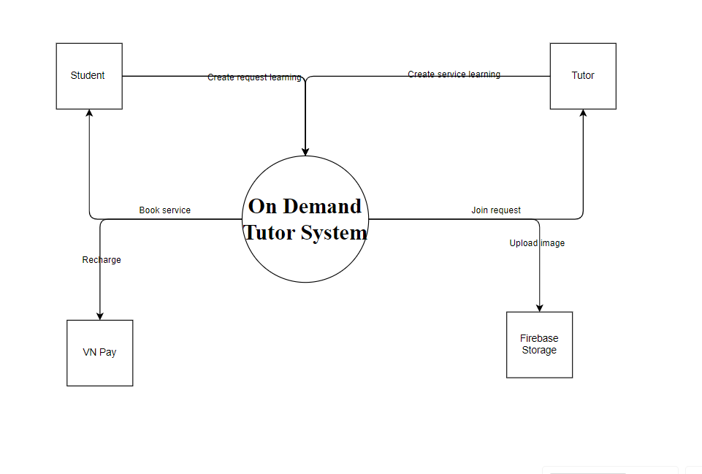

>>

## 2. User Requirements

### 2.1 Actors

| **#** | **Actor** | **Description** |
| --- | --- | --- |
| 1 | Guest | User not login in to system yet |
| 2 | Student | Students play a central role in the system, using the system's functions to search for tutors, attend lessons and manage their learning process. |
| 3 | Tutor | Tutors provide high quality educational services. They interact directly with students, prepare and deliver sessions, and support students in achieving their learning goals. |
| 4 | Admin | User manage all systems, responsible for everything from user management, data analysis, content moderation, to financial management. |
| 5 | Moderator | Users manage tutor requests and student requests as well as moderate content, track activity, and support for users . |

#### 2.2.1 Diagram

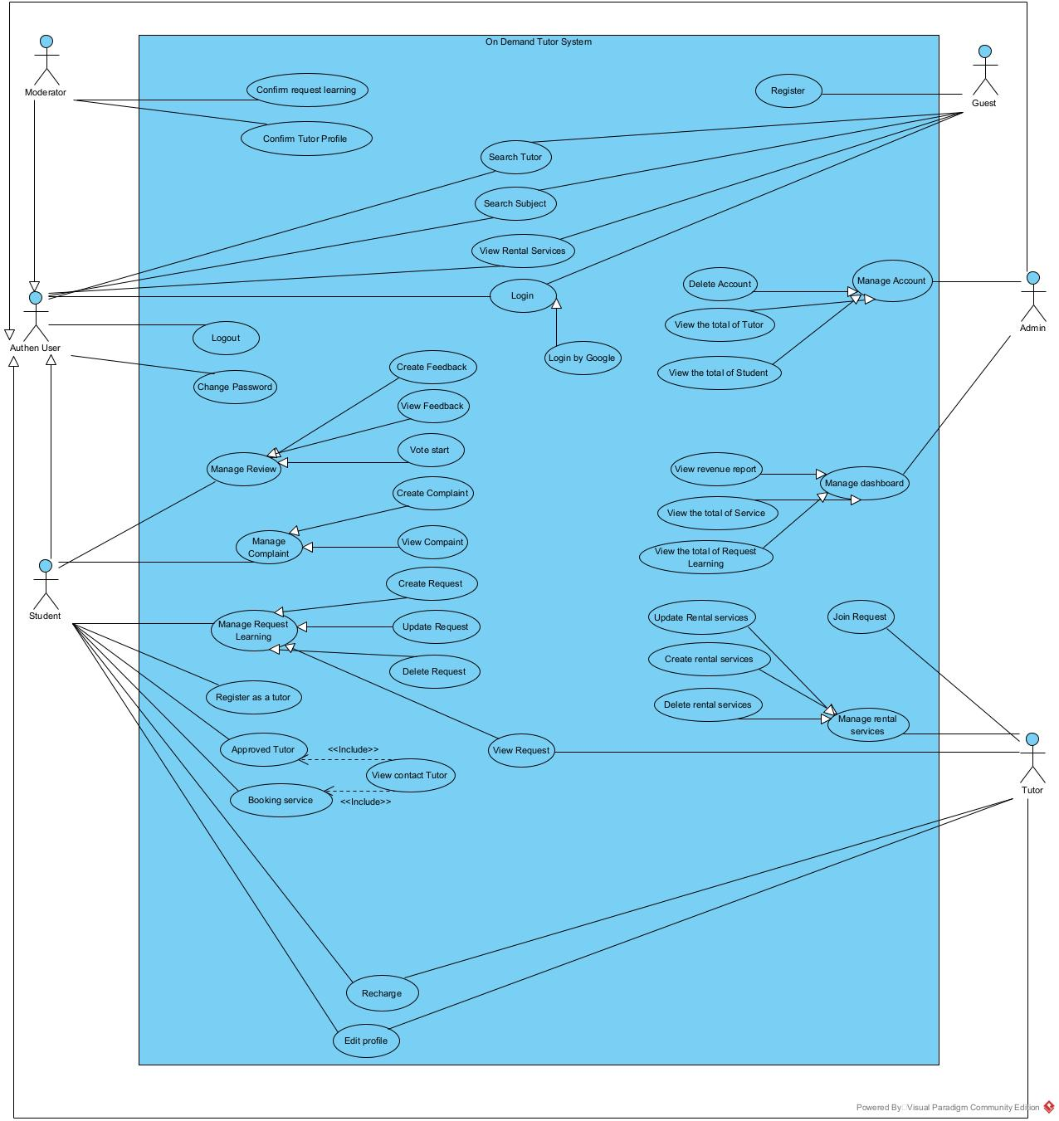

#### 2.2.2 Descriptions

*This part describes the use cases, you can follow the table form as below]*

| **ID** | **Use Case** | **Actors** | **Use Case Description** |
| --- | --- | --- | --- |
| UC-01 | Register | Guest | Allows users to register . |
| UC-02 | Login | Authen User | Enables registered users to log in to the system using their account credentials. |
| UC-03 | Login by Google | Authen User | Enables the users to log in to the system using their Google account credentials. |
| UC-04 | Logout | Authen User | This use case enables users to log out from the system. Upon logging out, the user's session is terminated, ensuring the security of their account. |
| UC-05 | Change password | Authen User | Allows users change their password |
| UC-06 | Get new password | Authen User | Allows users to retrieve new passwords using their Google account and log in to the system |
| UC-07 | Search Subject | Guest,Authen User | Allow users search for available subjects |
| UC-08 | Search Tutor | Guest,Authen User | Users search for tutors within the system. |
| UC-09 | View Rental Services | Student | Allows users to view created tutor services |
| UC-10 | Create Request | Student | Allows students to create study requests for tutors to participate |
| UC-11 | Update Request | Student | Allow students to change their academic requirements before approval |
| UC-12 | Delete Request | Student | Allows students to delete study requests before having a tutor participate in the request |
| UC-13 | View Request | Student | Allows students to view all study requests including unapproved, approved, ongoing and completed |
| UC-14 | Register as a tutor | Student | Allows users who already have a student account in the system and have enough information and qualifications to register to become a tutor |
| UC-15 | Approve Tutor | Student | Allows students to choose a tutor from among the tutors who have participated in the request to teach. |
| UC-16 | Booking Services | Student | Allow students to book the service that the tutor has created at a suitable time frame |
| UC-17 | View contact Tutor | Student | Allows students to view tutor contact information |
| UC-18 | Edit profile | Authen User | Allows users to edit their profile details. |
| UC-19 | View Profile | Authen User | Allows users to view their profile details. |
| UC-20 | Create Complaint | Student | Allows students to create complaints about tutors after the request or service ends |
| UC-21 | View Complaint | Student | Allows students to view their created complaints and reviewers to view complaints for processing |
| UC-22 | Create Feedback | Student | Allows students to create feedback after the request or service ends |
| UC-23 | View feedback | Tutor | Allow tutors to view student assessments and students to view their feedback |
| UC-24 | Vote Start | Student | Allow students to rate the tutor's service  by voting stars |
| UC-25 | Recharge | Student,Tutor | Allows students and tutors to deposit money into their accounts in the system |
| UC-26 | Confirm Tutor Profile | Moderator | Allow moderators to review the information of a student's request to become a tutor, accept or decline the request |
| UC-27 | Confirm Request Learning | Moderator | Allows moderators to review learning requests to reject or accept |
| UC-28 | Delete Account | Admin | Allows system administrators to delete accounts |
| UC-29 | View information of all students | Admin | Allows administrators to view all student information |
| UC-30 | View information of all tutors | Admin | Allows administrators to view all tutor information |
| UC-31 | View revenue report | Admin | Allows admin to view revenue reports. |
| UC-32 | Delete Account | Admin | Allows admin to delete user’s account from database |
| UC-33 | View all requests | Admin | Allows administrators to view all student requests |
| UC-34 | View all rental services | Admin | Allows administrators to view all tutor services |
| UC-35 | Join Request | Tutor | Tutors can approved request of student |
| UC-36 | Create Service | Tutor | Allow tutor can create sercices |
| UC-37 | Update service | Tutor | Allow tutors to update the service before students register for the service |
| UC-38 | Delete service | Tutor | Allow tutors to delete the service before students register for the service |

## 3. Functional Requirements

### 3.1 System Functional Overview

#### 3.1.1 Screens Flow

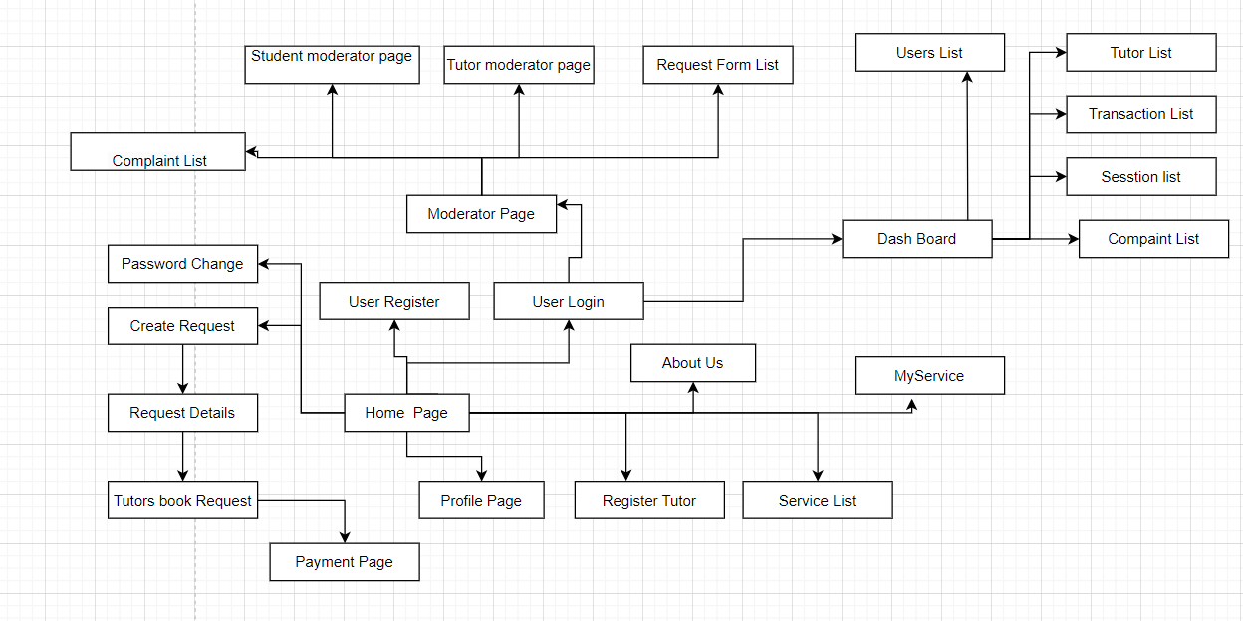

#### 3.1.2 Screen Descriptions

### 

| **#** | **Feature** | **Screen** | **Description** |
| --- | --- | --- | --- |
| 1 | Account management | User Register | Screen with mandatory fields must be entered such as username and password, confirm password |
| 2 | Account management | User Login | Screen with mandatory fields must be entered such as username and password |
| 3 | Account management | Profile Page | Screen with all information about user |
| 4 | Account management | Register Tutor | Screen of user destine for who in need become tutor  with all necessary field such as certificate file and others |
| 5 | Account management | Password Change | Screen with password, confirm password field and confirm change button |
| 7 | Tutor management | Tutor list | Screen displays a list of available tutors. |
| 8 | Tutor management | Tutor Detail | Screen provides detailed information about a specific tutor, including their profile, qualifications, and reviews. |
| 9 | Tutor management | Schedule | Screen allows users to view and manage their schedule, including upcoming tutoring sessions. |
| 10 | Payment management | Payment Page | Screen is used for handling payments, including entering payment details and processing transactions. |
| 11 |  |  |  |
| 11 | Moderator management | Moderator Page | Screen is for moderators to approve tutor service, student request, handle reports, and perform other administrative tasks. |
|  |  |  |  |
| 8 | Tutor management | Tutor Detail | Screen provides detailed information about a specific tutor, including their profile, qualifications, and reviews. |
| 9 | Tutor management | Schedule | Screen allows users to view and manage their schedule, including upcoming tutoring sessions. |
| 15 | Tutor management | Session list | This screen shows a list of tutoring sessions, both past and upcoming. |
| 10 | User post | Post Detail | Screen displays information about student posts, such as a discussion or request. |
| 11 | User post | Request list | Screen to see whether student or tutor requests have been approved or are being approved |
| 12 | User post | Create Request | The screen displays a form so students or tutors can create requests |
| 11 | Moderator management | Moderator Page | Screen is for moderators to approve tutor service, student request, handle reports, and perform other administrative tasks. |
| 13 | Dashboard management | Dashboard | Screen provides an overview of tutor and student list, list of request and revenue. |
| 10 | Payment management | Payment Page | Screen is used for handling payments, including entering payment details and processing transactions. |
| 14 | Account management | User detail (tutor) | Screen provides detailed information about a tutor, similar to the Tutor Detail screen for admin to see. |
| 16 | Account management | User detail (student) | Screen provides detailed information about a student, similar to the Student Detail screen for admin to see. |

#### 3.1.3 Screen Authorization

| **Screen** | **Student** | **Tutor** | **Admin** | **Moderator** |
| --- | --- | --- | --- | --- |
| User Register | X | X |  |  |
| User Login | X | X |  |  |
| Profile Page | X | X |  |  |
| Register Tutor |  | X |  | X |
| Password Change | X | X |  |  |
| Home Page | X | X | X | X |
| Tutor list | X | X |  | X |
| Tutor detail | X | X |  | X |
| Schedule | X | X |  | X |
| Payment Page | X | X |  |  |
| Moderator Page |  |  |  | X |
| Post Detail |  |  |  |  |
| Dash Board |  |  | X |  |
| User detail (tutor) |  |  | X |  |
| Session list |  |  | X |  |
| User detail (student) |  |  | X |  |

### 3.2 Feature

#### 3.2.1 Login

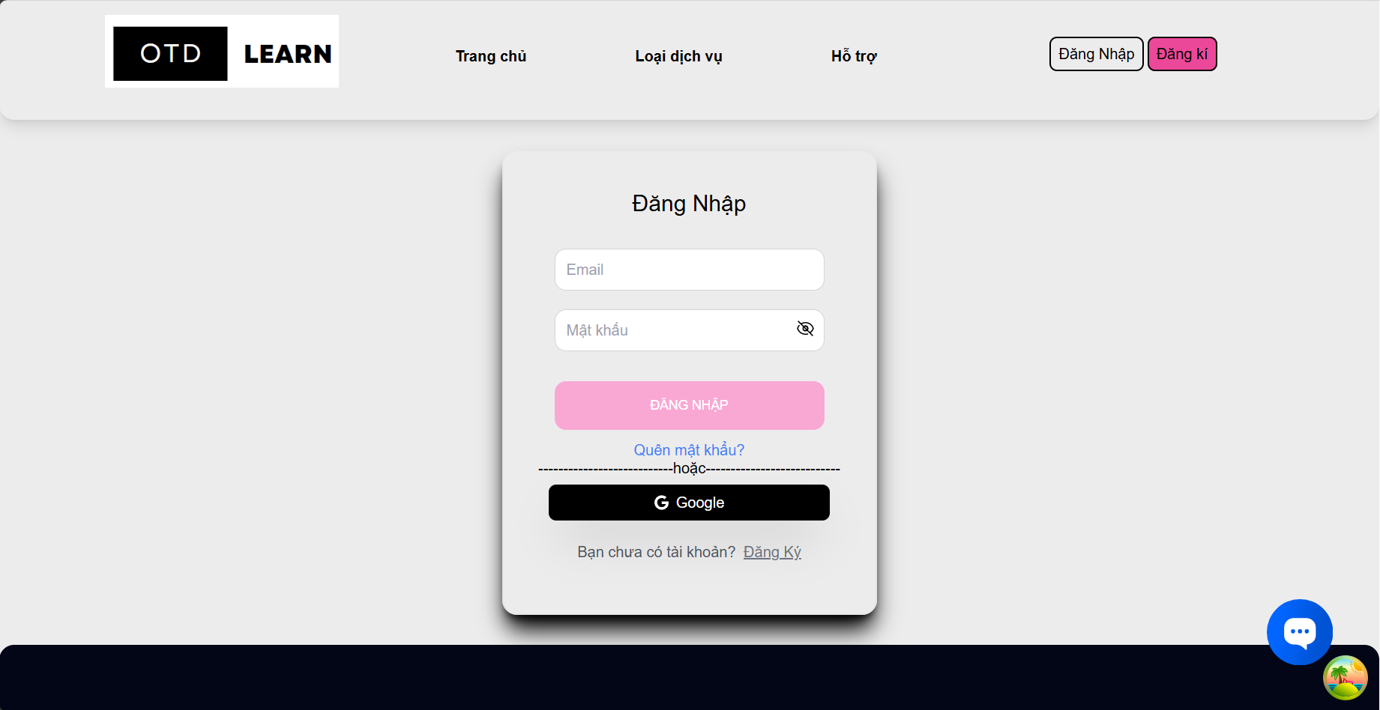

*]*

#### 3.2.2 Register

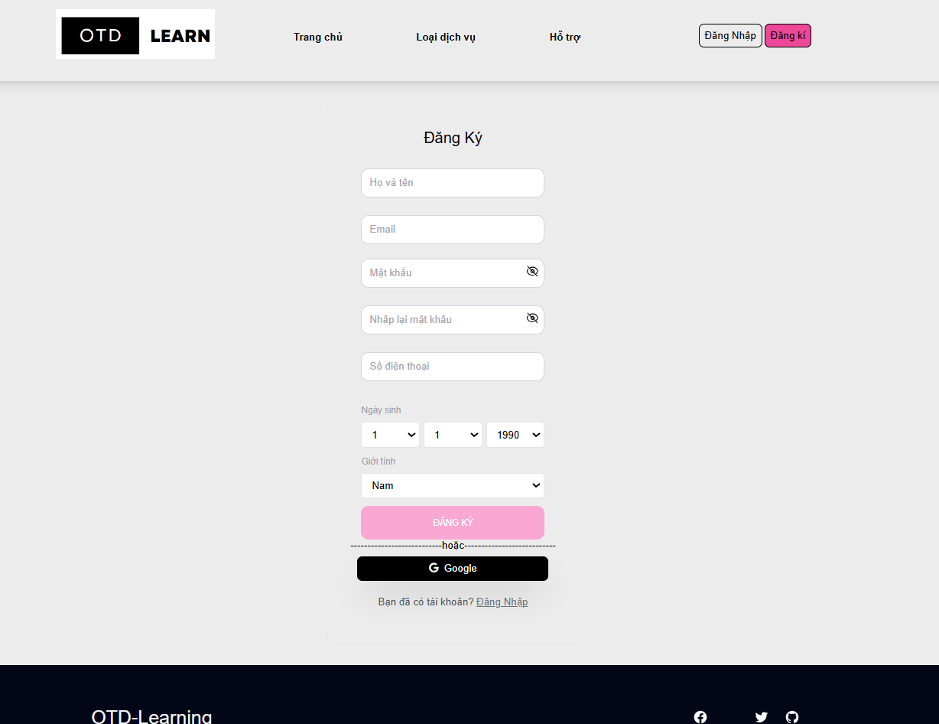

#### 3.2.3 Register As Tutor

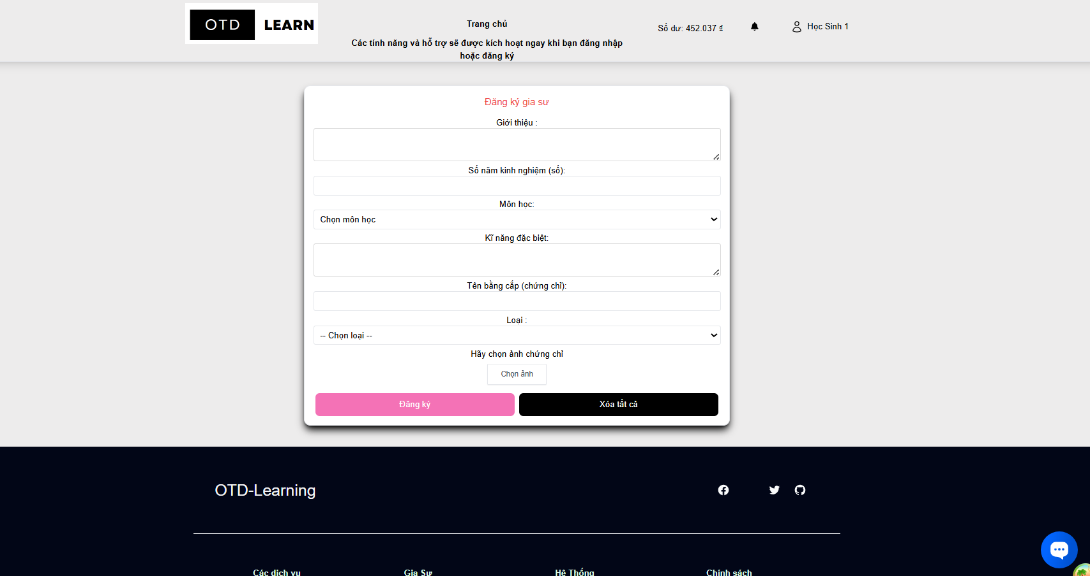

#### 3.2.4 Recharge

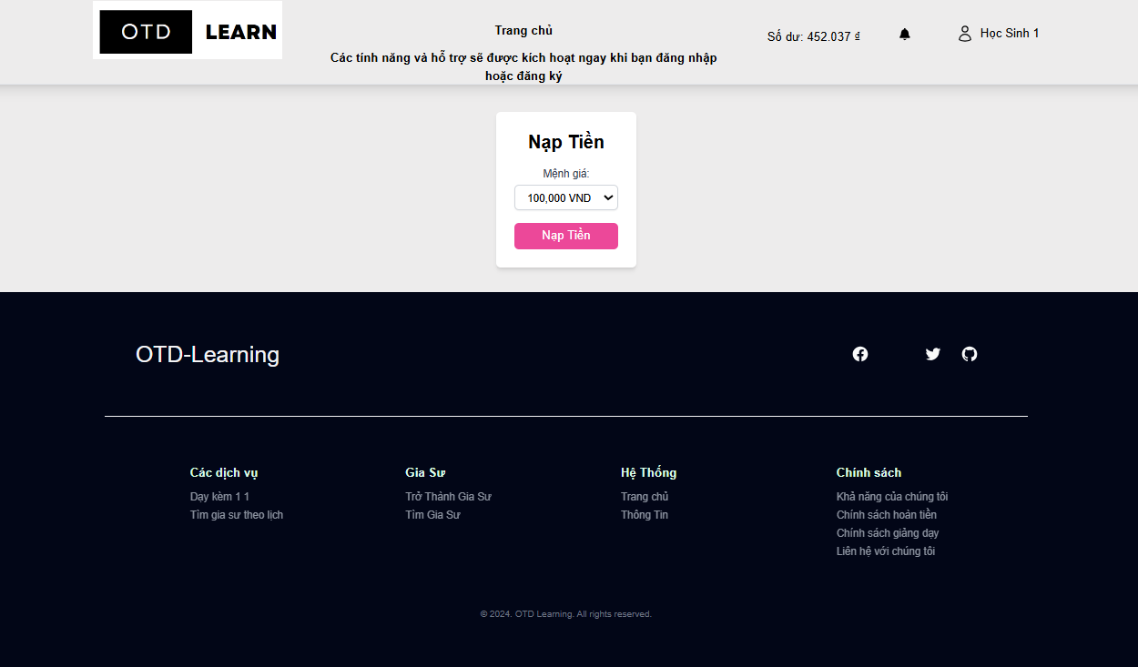

#### 3.2.5 Create Request Lerning

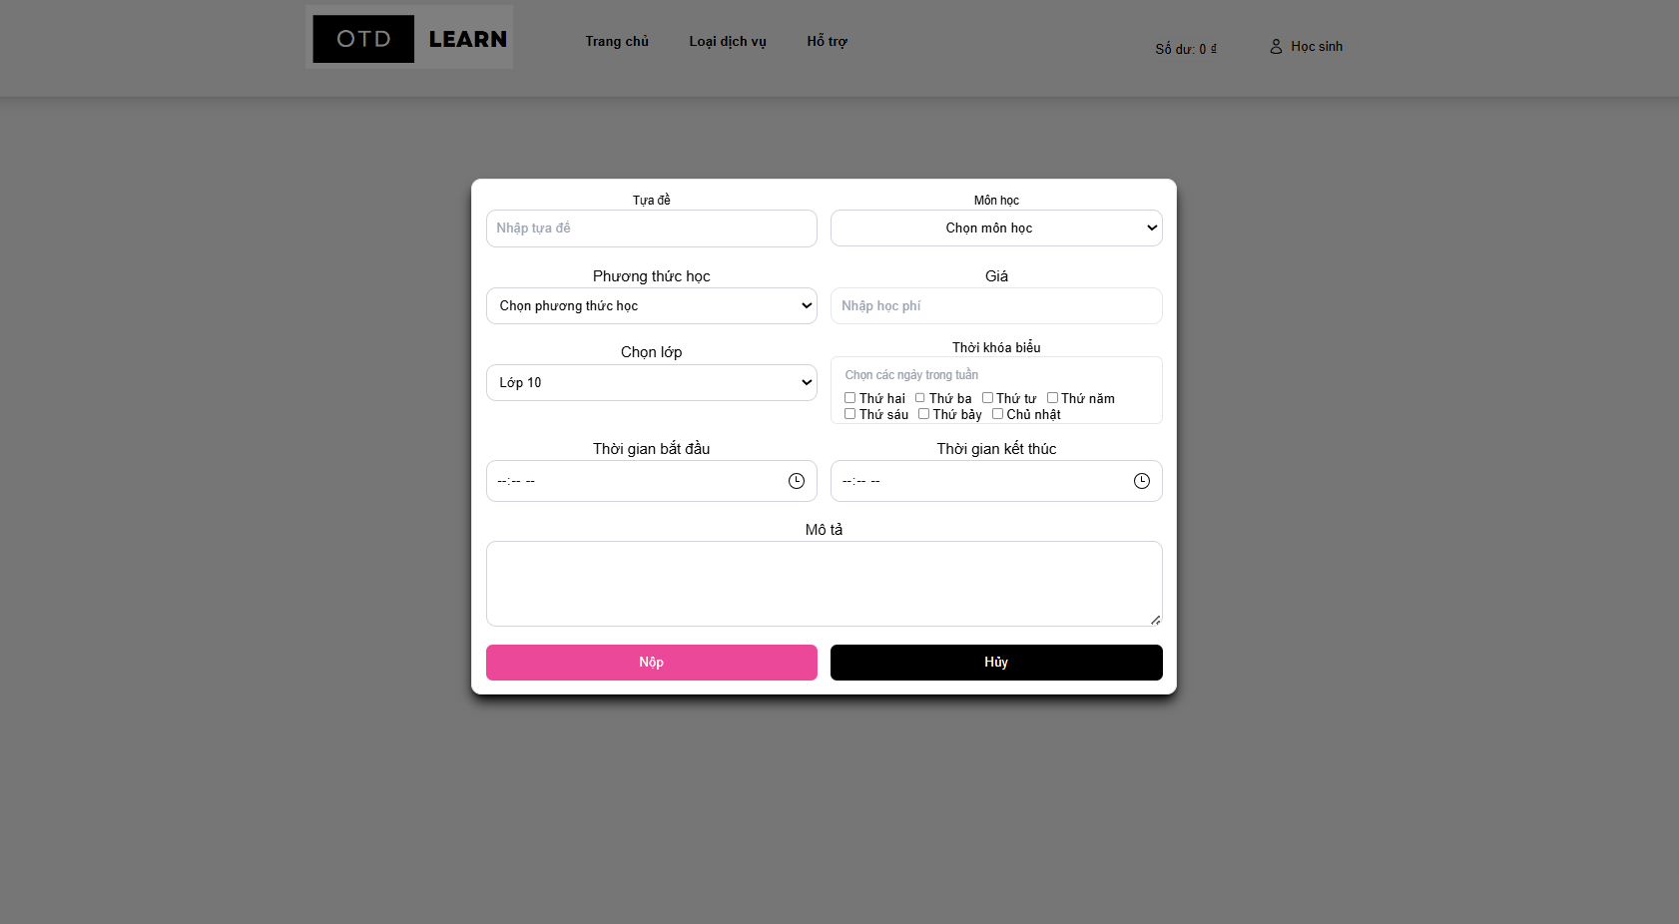

#### 3.2.6 Create Service Lerning

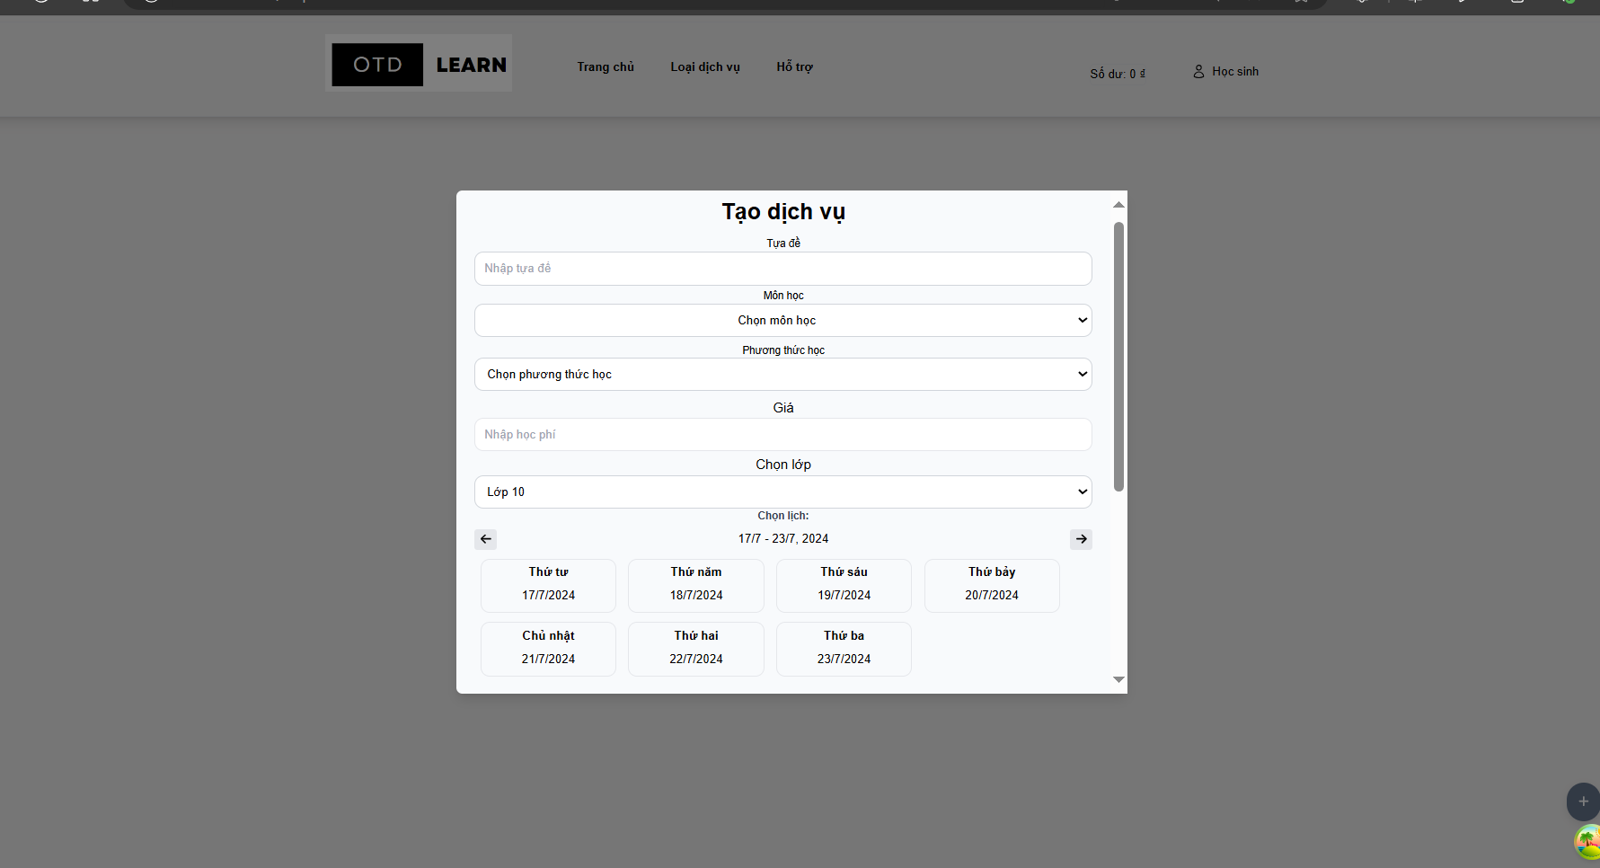

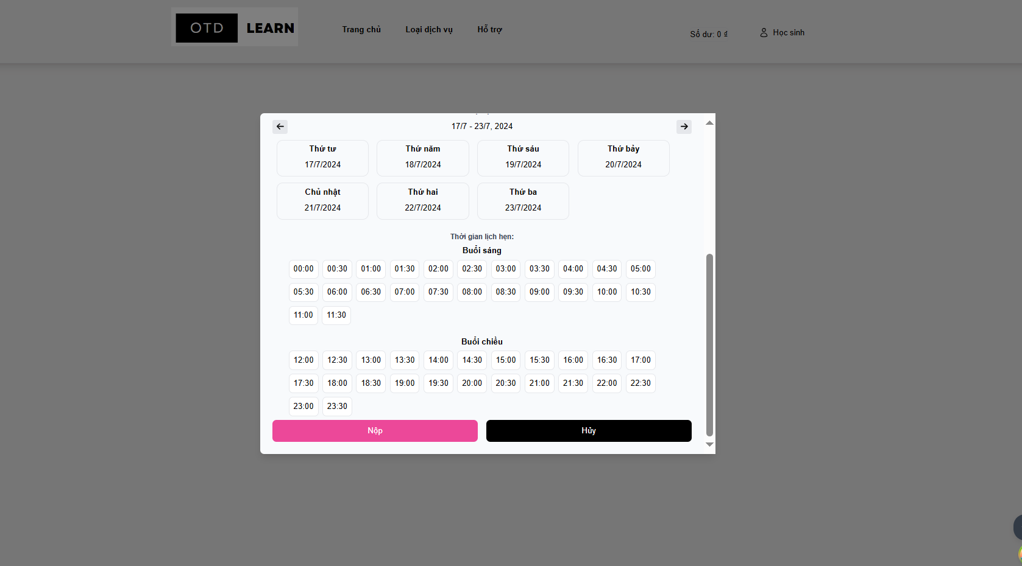

#### 3.2.7 View Revenue

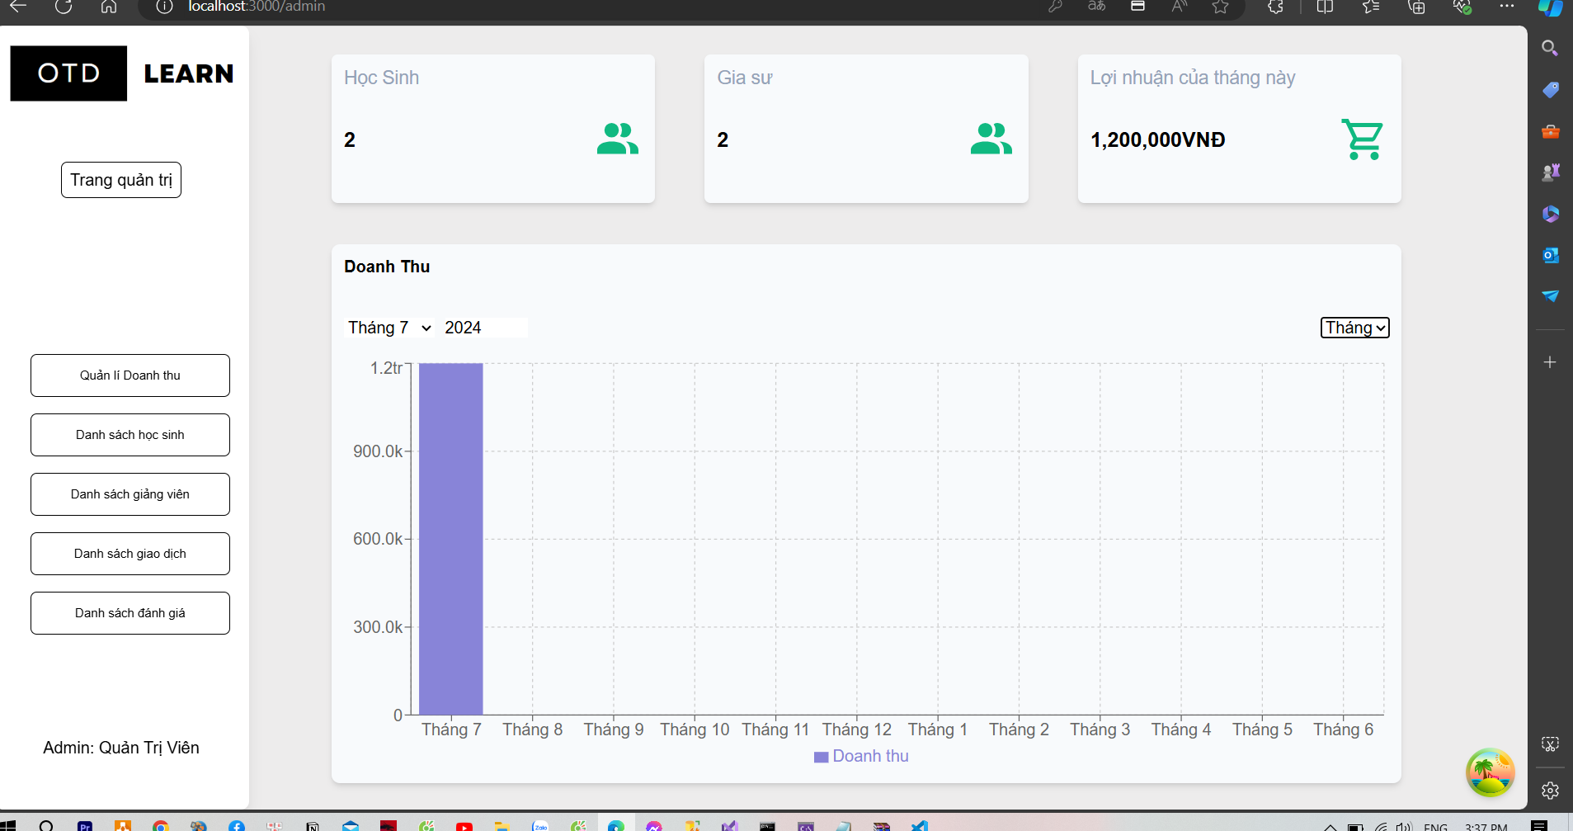

#### 3.2.8 View Account

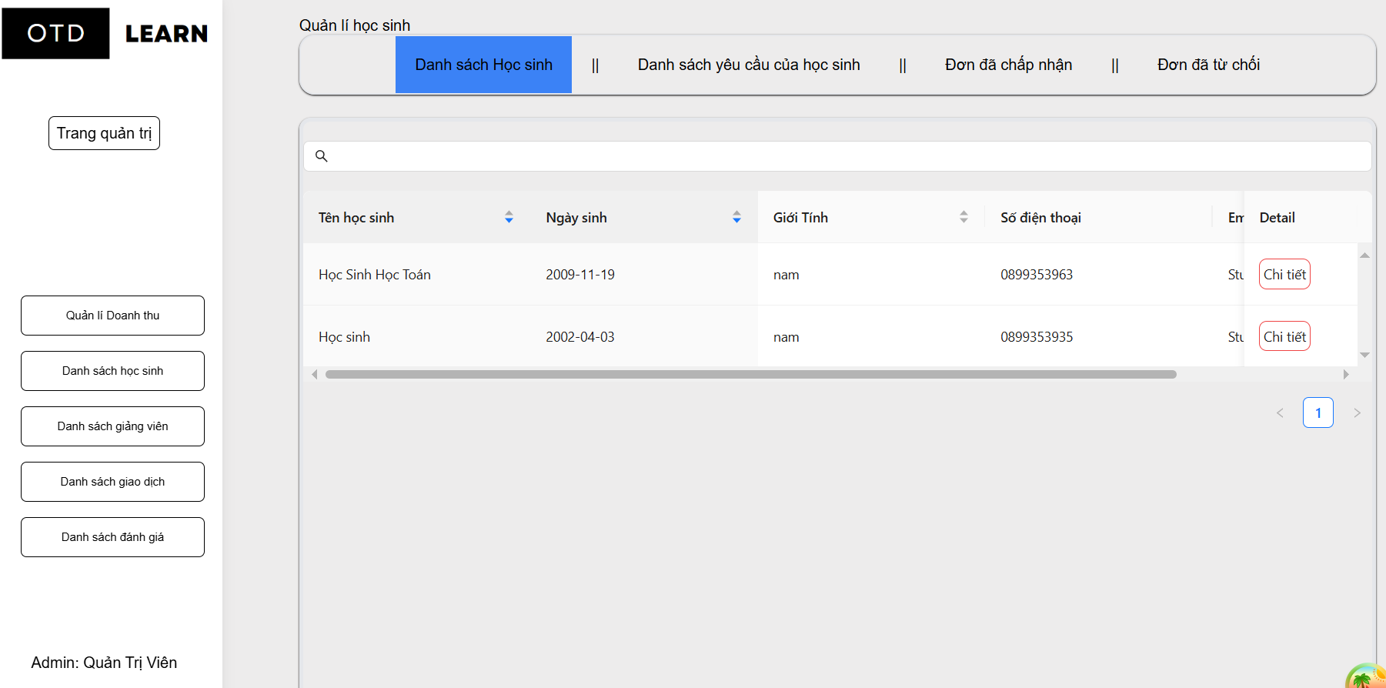

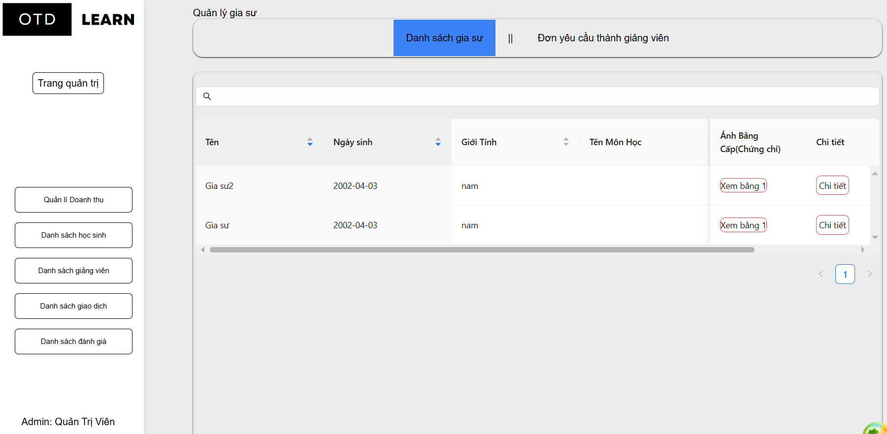

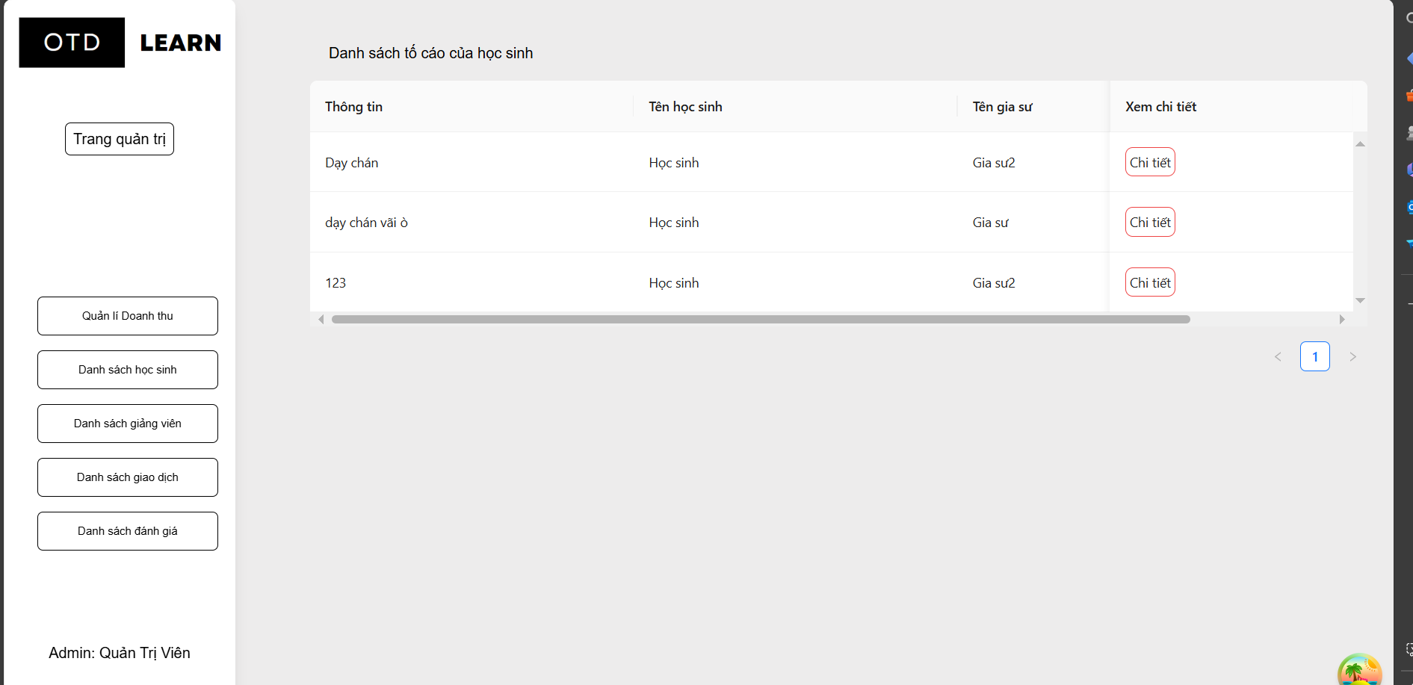

#### 3.2.9 View Transaction

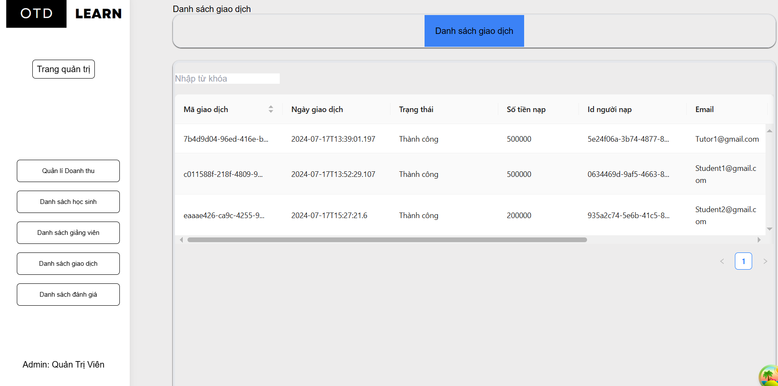

## 4. Requirement Appendix

## 

| **ID** | **Category** | **Rule Definition** |
| --- | --- | --- |
| **BR-01** | Learning Management Requirements | When a student chooses 1 tutor from many tutors who have joined their request, the system will receive 50,000 VND from the tutor's account in the system. |
| **BR-02** | Service management | When a student makes a booking for a service from a tutor, it is required to have money in the system, so the student will perform the recharge function first. |
| **BR-03** | Service management | When a student makes a booking for a service from a tutor, the system will receive 10% of the student's booking fee |
| **BR-04** | Service management | When a student makes a booking for a service from a tutor, and after the student chooses to end the class, 90% of the money from the booking will be transferred to the tutor's account. |
| **BR-05** | Tutor management | Before the tutor can perform the function of participating in the request, there must be 50,000 VND in the tutor's account. |